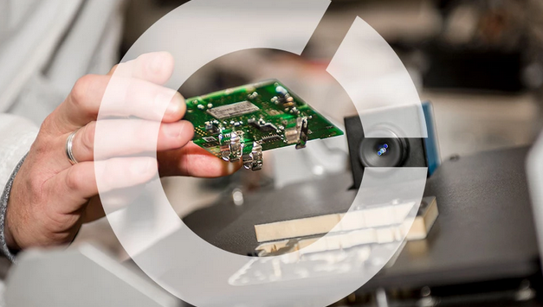

|  |
| --- |
|  |
| System Design Document  Comfort Home |
| |  |  |  | | --- | --- | --- | | Group 5 | 9/17/20 | T2-CB01 project | |

Author(s): Toma Krastanov – 3774678

Rami Alramadan – 3936767

Sjuul de Lang – 4023935

Jorrit van Triest – 4081722

Fabian Ifionu – 3886913

Contents

Document history 2

1. Introduction & Project Description 3

2. System description 3

3. Use cases 4

4. System Hardware Modules 6

5. System Design 9

5.1. System Context 9

5.2. Subsystems 10

5.2.1. Sensor Module 10

5.2.2. Ventilation Box 10

5.3. State Diagram 12

5.4 Flow chart 13

6. Communication protocol 13

References 14

# Document history

|  |  |  |  |  |  |
| --- | --- | --- | --- | --- | --- |
| **Version** | **Date** | **Status** | **Author** | **Description** | **Remarks** |
| 0.1 | 2020-Sep-27 | Draft | Group | Creation |  |
| 0.2 | 2020-Oct-06 | Draft | Group | Combine everybody’s work | Awaiting Coach Review |
| 0.3 | 2020-Oct-08 | Finished | Group | Small changes from coach feedback |  |
|  |  |  |  |  |  |

­­

# Introduction & Project Description

For this semester we were tasked by the company Airios to create an automatic ventilation system that ventilates the air based on the measurements of different sensors to maintain a clear environment in a room with as less as possible user interaction.

Global warming is a reality bringing about serious weather changes, in some parts of the world due to lots of cold houses are becoming more and more insulated which comes with both health problems and condensation which causes damages to our home. We are building a system that can ventilate a house based on measurements done by wireless sensors that measure CO2, Humidity, Temperature and Particulate matter.

# System description

The following sensors are connected to a STM Nucleo-64 board. CM-1106 CO2 Sensor communicating through UART. Sensirion SHT3x Humidity/Temperature Sensor communicating through I2C and iAQ-Core Particulate Matter sensor communicating through I2C. These sensors will communicate with the ventilation box over ZigBee to reduce temperatures, decrease VOC concentrations, lower concentration of Radon gas to improve a healthier environment. The ventilation box will be simulated via C# application. The sensors will be connected to a shield that is placed on top of the Nucleo board. Communications between these Sensors and the Ventilation box will be bi-directional. The measurements will be sent to the Ventilation box at least every 15 minutes or when there is a sharp increase or decrease in the data readings. LEDs will be used as indicators – if there is a communication loss it will blink red; the LED will show if the Ventilation box (C# application) is using its value to control the ventilation speed. Ventilation box logs all the data from the connected sensors.  The system can also be expanded by adding more sensors. The algorithm in the Ventilation box decides if it should control the ventilation based on CO2, Humidity, VOC, or Temperature.

# Use cases

Figure 1 – Use cases diagram

Figure 1 depicts some of our use cases and depicts how the actors are going to interact with the overall system that we are building.

|  |  |
| --- | --- |
| **Use Case ID:** UC_001 | **Use Case:** Change Temperature |
| **Description** | The user can change the temperature |
| **Actor:** | End User |
| **Use Case ID:** UC_002 | **Use Case:** Measure CO2 |
| **Description** | The CO2 sensor continuosly measures the CO2 levels in the room |
| **Actor:** | CO2 sensor |
| **Use Case ID:** UC_003 | **Use Case:** Measure VOC |
| **Description** | The particle matter sensor measures the VOC levels in the room |
| **Actor:** | VOC sensor |
| **Use Case ID:** UC_004 | **Use Case:** Measure Temperature |
| **Description** | The temperature sensor measures the temperature in the room |
| **Actor:** | Temperature sensor |
| **Use Case ID:** UC_005 | **Use Case:** Measure Humidity |
| **Description** | The humidity sensor measures the humidity levels in the room |
| **Actor:** | Humidity sensor |
| **Use Case ID:** UC_006 | **Use Case:** Activate/Deactivate Fan |
| **Description** | System activates/deactivates the fan based on an algorithm |
| **Actor:** | Fan |
| **Use Case ID:** UC_007 | **Use Case:** Set Fan Speed |
| **Description** | User will be able to manually set the fan speed |
| **Actor:** | User |
| **Use Case ID:** UC_008 | **Use Case:** Establish Connection |
| **Description** | The ZigBee connects to the simulated C# ventilation box so it can send the values that the sensors measure from the room |
| **Actor:** | ZigBee module |
| **Use Case ID:** UC_009 | **Use Case:** Lose Connection |
| **Description** | When the ZigBee loses connection to the ventilation box the red LED on the shiled will start blinking |
| **Actor:** | ZigBee module |

Table 1 – Table with use cases that determine the system’s functionality

# System Hardware Modules

4.1 Nucleo Board – Nucleo F303RE

We are using the Nucleo F303RE Nucleo board that was provided to us by the ISSD. The shield provided by the company will be attached to this board and all our code will be uploaded to it. In Figure 1 a picture of the board can be seen.

Figure 2 – Picture of the Nucleo F303RE board

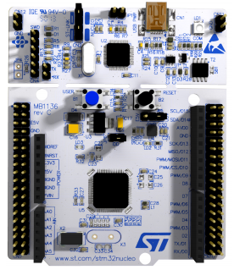

4.2 CO2 Sensor – CM-1106

The CM-1106 CO2 sensor will be connected to the shield provided by Airios which will be on top of the Nucleo board. The sensor will use UART communication so it can measure the CO2 levels in a room. In Figure 2 the pin assignment can be seen. (CM-1106)

Figure 3 – CU-1106 pin assignment

4.3 Temperature/Humidity Sensor – SHT3x

The SHT3x sensor will be used to monitor the temperature and humidity levels in the room and send them to the ventilation box. The sensor will be attached to the Airios shield and uses I2C communication. In Figure 3 the pin assignment for the sensor can be seen. (SHT3x)

Figure 4 – SHT3x pin assignment

4.4 VOC Sensor – iAQ-Core

For the monitoring of particulate matter in the air e are using the iAQ-Core VOC sensor which will also be connected to the Airios shield and will use I2C communication to measure data. In Figure 4 the pin assignment of the sensor can be seen. (iAQ-core)

Figure 5 – iAQ-Core pin assignment

4.5 ZigBee Module – ZigBee-ETRX357

To send the data from the Nucleo board to our C# simulated ventilation box we are going to use a ZigBee which allows us to wirelessly transmit data. The ZigBee will also enable us to communicate with the other groups’ modules, so each system always knows what the conditions in the other rooms are.

# System Design

# System Context

Figure 6 – System Context Diagram

The sensor module connects to the ventilation box via ZigBee, after which the ventilation box sends a heartbeat signal at a regular interval, the module sends back an acknowledgement.

The sensors send their respective measurements to the module in an appropriate unit of measurement.

The sensor data is then sent to the ventilation box, the ventilation box in return sends a usage signal when the data it received triggered a control response in the ventilation box (change LED colour).

The ventilation box controls the speed of the fan by PWM based on the sensor data it received from the sensor module.

# Subsystems

# Sensor Module

All the sensors and the ZigBee module will be connected to the main sensor module which is the shield provided to us by Airios. The shield will be put on top of our Nucleo board. In Figure 7 the wiring of all the components on the shield (sensors and ZigBee module) as well as what type of communication they use (UART or I2C) can be seen.

Figure 7 – Wiring diagram of the shield

# Ventilation Box

In the place of a physical component, the fan and related user interface will be simulated through a C# application, processing the data received by the other sensors of the Indoor Climate Control.  
The sensor’s readings are transferred wirelessly through the ZigBee, and displayed on individual segments of the UI. These readings will influence the fan through PWM to maintain comfortable conditions in the inside of the Comfort Home.  
The ventilation box will also supply a heartbeat to ensure connectivity between itself and the connected hardware.

The wireframe below shows a proposed user interface, where most of the components are read-only to provide the user with direct feedback of the sensor data. The user is limited to

changing some personal preferences in their own Comfort Home.

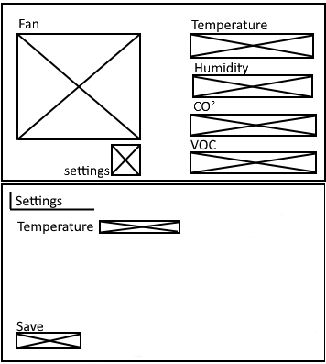

Figure 8 - Proposed UI Wireframe

# State Diagram

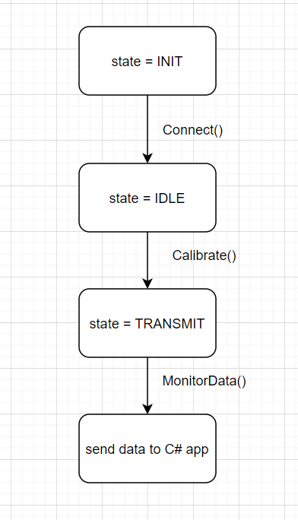

Figure 9 – Data Transmission state diagram

This state diagram showcases how the sensor readings are going to be transmitted from the sensor module to the simulated ventilation box

# 5.4 Flow chart

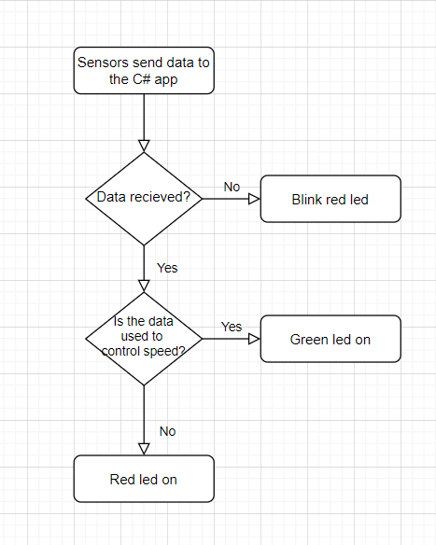

Figure 10 – The flow chart shows how the ventilation box uses the sensor readings and the visual feedback it gives the senor module (LEDs)

# Communication protocol

All the groups will be working together to come up with a good protocol for the ZigBee communication so each group can have the others’ readings. Here is a concept design for the protocol:

$ start of message.

Temp command.

= separator.

ON/OFF value.

% end of message.

# References

CM-1106 - <https://52ebad10ee97eea25d5e-d7d40819259e7d3022d9ad53e3694148.ssl.cf3.rackcdn.com/W-Cubic_CM1106_DS.pdf>

SHT3x – <https://www.mouser.com/datasheet/2/682/Sensirion_Humidity_Sensors_SHT3x_Datasheet_digital-971521.pdf>

iAQ-Core – <https://www.mouser.com/datasheet/2/588/iAQ-core_DS000334_1-00-1512544.pdf>